Name: ______________________________ Due: 5/7 This is worth 3 hw points!!
Constructions Regents Review #1
1.
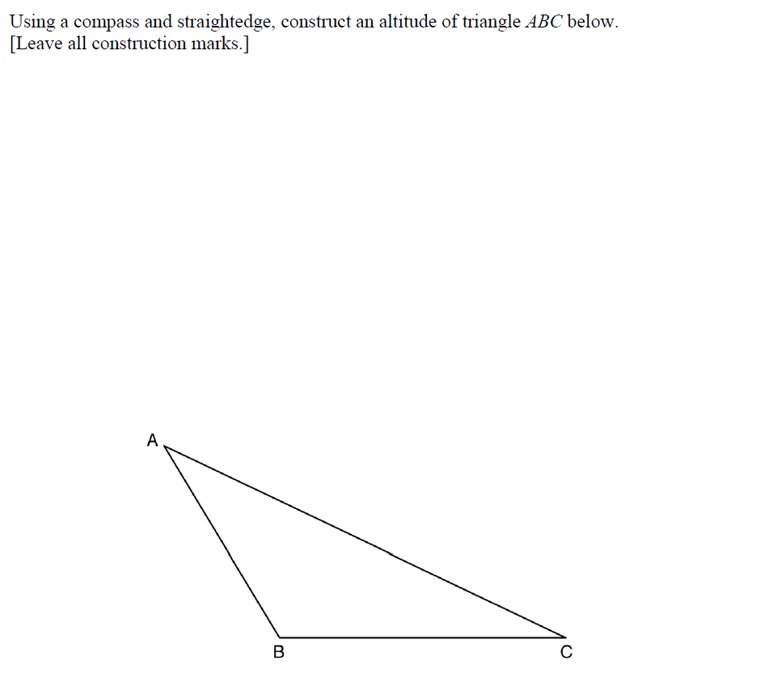

2. Using a compass and a straightedge, construct a median from vertex C.

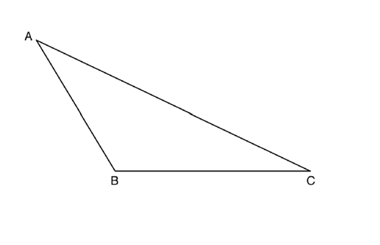

3. Given: Line segments a and b
Construct a line segment with length 2a + b

4. Using a compass and straightedge, construct a line that passes through point P and is perpendicular to line m. [Leave all construction marks.]

5. Which diagram shows the construction of a 45° angle?
1) | 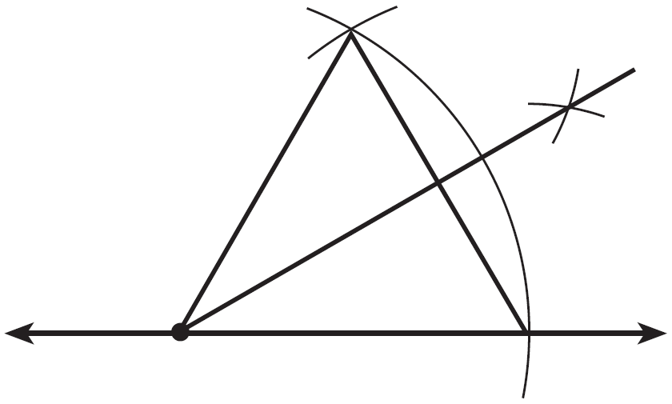 | 3) | 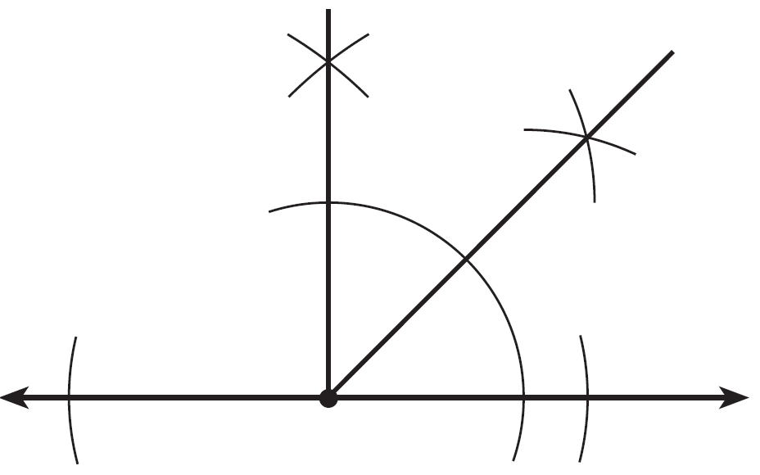
2) | 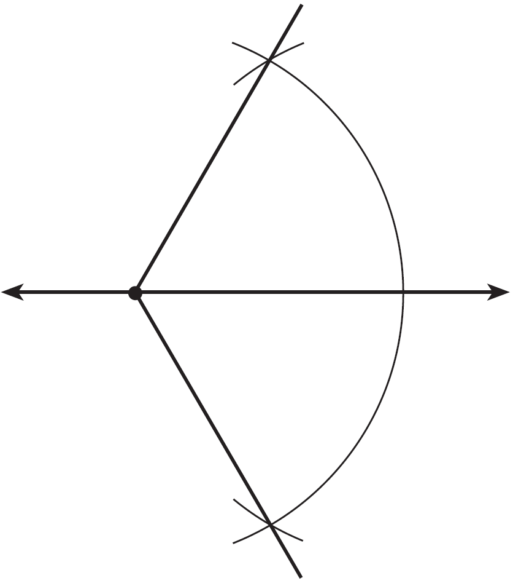 | 4) | 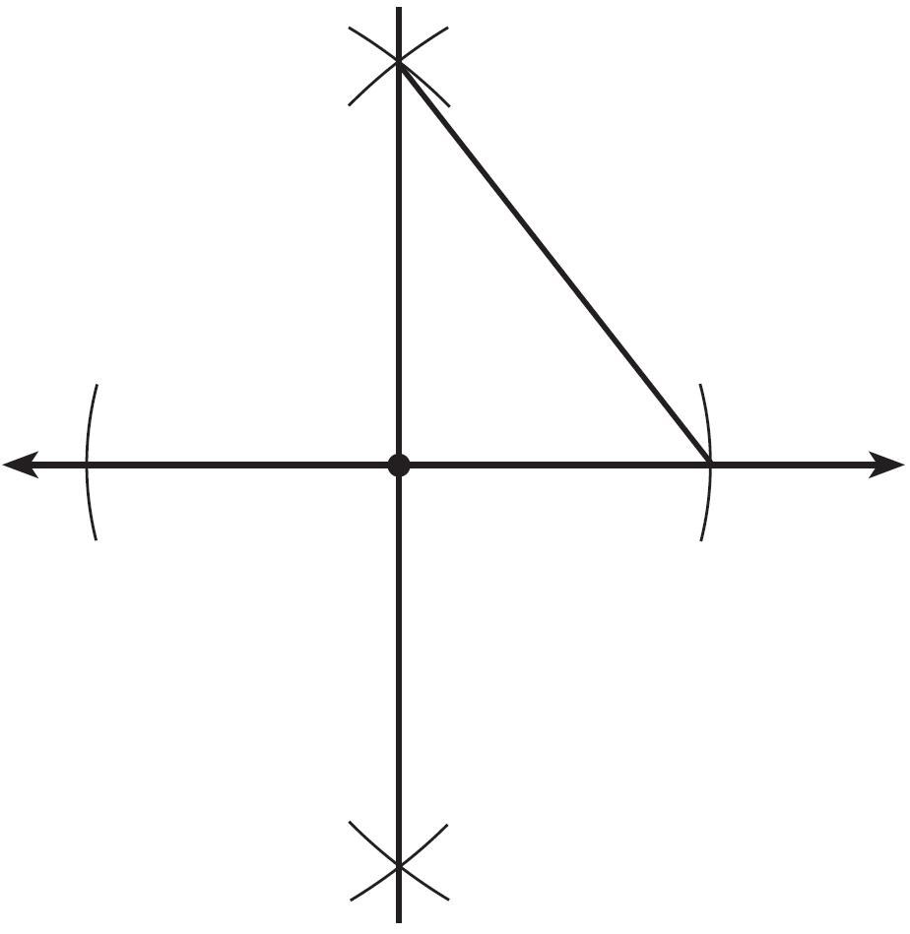

6. Use a compass and straightedge to divide line segment AB below into four congruent parts. [Leave all construction marks.]

7. Using a compass, partition the line segment into a 2:3 ratio.

8. On the ray drawn below, using a compass and straightedge, construct an equilateral triangle with a vertex at R. The length of a side of the triangle must be equal to a length of the diagonal of rectangle ABCD.

9. Construct a line parallel to line segment AB.

10. Bisect angle B

